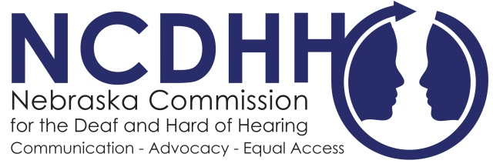
Media Contact:
Kelsey Cruz
4600 Valley Road Suite 420
Lincoln, NE 68510-4844
(402) 471-3593
Kelsey.Cruz@nebraska.gov

For Immediate Release:
August 23, 2017

HUSKERS TO IMPLEMENT NEW PILOT CAPTIONING PROGRAM
After collaboration with NCDHH, the Nebraska Huskers will now introduce a new pilot captioning program to improve the fan experience for all Nebraskans and Husker fans alike in Memorial Stadium for the 2017-2018 football season.
All play descriptions, scoring, player information, referee and penalty announcements, in-game promotions, entertainment action, advertising videos, emergency message, and post-game messages will be transcribed. The information will be distributed to all fans via Twitter at @HuskerCaption. Fans who do not have devices enabled to access Twitter may check out iPads at the East and West Stadium Guest Services.
This comes on the heels of meetings NCDHH had with UNL after research on how other stadiums around the country are ensuring full communication access for all, including closed captioning.
“We are encouraged by the responsiveness the University has had to our concerns about communication access,” NCDHH Executive Director John Wyvill said. “We are hopeful and optimistic about the outcome of this pilot program.”
Following the football season, Nebraska Athletics and the ADA/504 Compliance Officer welcomes all fan input and will review information received on the program to conduct a fan focus group across the state before making decisions going forward regarding captioning via Twitter. Fans are encouraged to share their game-day experience to the ADA/504 Compliance officer at access@unl.edu.
#

