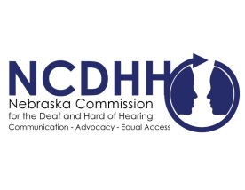
Pete Ricketts  Governor  Candice Arteaga,  Chairperson  Commission Members  Frances Beaurivage  Lincoln  Jonathan Scherling  Omaha  Jeremy Fitzpatrick  Omaha  Dr. Stacie Ray  Lincoln  Norman Weverka  Brainard  Robert Feit  Lincoln  Sandra Shaw  Seward  Diane Schutt  Fairbury  John C. Wyvill Executive Director | Accepting Applications for LEAD-K Advisory Committee  Governor Ricketts signed LB 965 “LEAD-K bill” into law. The bill will establish a language assessment program for children who are deaf or hard of hearing. Under LB 965 will be an advisory committee. NCDHH and NDE are looking for qualified applicants to apply for the committee, dedicated to compile data from assessments and research program. The role of the advisory committee is to identify existing resources already developed and made available for use by families, local education agencies, individual family service programs or individual education plans.  Applications will be reviewed and selected with consultation by NDE and NCDHH, the committee will be comprised of a cross section of educators, administrators, deaf and hard of hearing community organization representatives and parents of children who are deaf and hard of hearing. The goal is to have a wide range of people with different experience, perspective and expertise.  The committee is volunteer only, with communication access provided for each meeting. The first meeting is required attendance and will take place on December 16th at 10:00am-2:00pm in Lincoln with location TBD.  More information on LB 965 can be found at: https://nebraskalegislature.gov/FloorDocs/106/PDF/Intro/LB965.pdf  To apply for the LB 965 advisory committee, please go to: https://ncdhh.nebraska.gov/sites/ncdhh.nebraska.gov/files/doc/LEAD-K%20application%209.23.22.pdf  #  To unsubscribe from the E-Communicator, reply to this email with “Unsubscribe from E-Communicator” in the subject line of the message.

